Final Assignment

Summer 2024

Course Title: Introduction to Programming

Course Code: CSE 1102

Submitted by:

NORE ALAM TUHIN

241014109

Department of CSE

University of Liberal Arts Bangladesh (ULAB)

Question 1:

CO1 a) In a local grocery store, customers purchase items, and the store needs to

calculate various costs based on quantities and prices. Imagine you are tasked with

determining the total cost of items using C programming concepts. Discuss how

you would declare and use variables to store the price and quantity of three

different items (apples, bread, and milk). Additionally, explain which arithmetic

operators you would use to calculate the total cost of the items, apply a 5% sales

tax, and display the final amount. You may assume that the price and quantity are

simple integers or floating-point numbers. How would you ensure accuracy in your

calculations using C operators?

ANS: #include <stdio.h>

int main() {

float price_apples, price_bread, price_milk;

int quantity_apples, quantity_bread, quantity_milk;

price_apples = 1.50;

price_bread = 2.00;

price_milk = 3.00;

quantity_apples = 4;

quantity_bread = 2;

quantity_milk = 1;

float total_cost = (price_apples * quantity_apples) + (price_bread * quantity_bread) + (price_milk * quantity_milk);

float sales_tax = total_cost * 0.05;

float final_amount = total_cost + sales_tax;

printf("Total cost before tax: $%.2f\n", total_cost);

printf("Sales tax (5%%): $%.2f\n", sales_tax);

printf("Final amount: $%.2f\n", final_amount);

return 0; }

b) Design a flowchart that accepts two numbers as input and uses `if-else`

statements to determine the appropriate arithmetic operation based on the values of

the numbers. If both numbers are positive, the flowchart should calculate and

display their sum. If one number is positive and the other is negative, it should

calculate and display their product. Lastly, if both numbers are negative, the

flowchart should compute and display their absolute difference. The flowchart

should visually represent the decision-making process, showing the conditional

checks with `if-else` statements and the corresponding arithmetic actions.

ANS;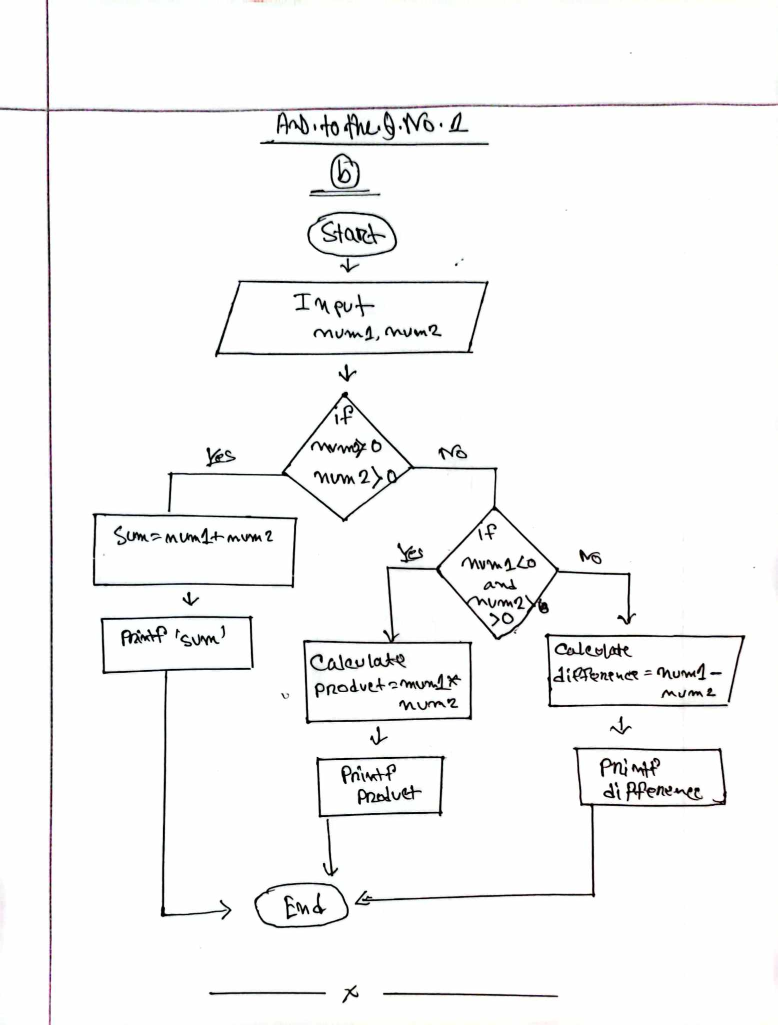

Question 2:

Write a C program to calculate the energy required to turn ice into steam. The

program should take two inputs: the initial temperature of the ice (in Celsius) and

the weight of the ice (in kilograms). The output should display the total energy

consumed to turn the ice into steam.

Input: temperature, weight ⇒ -10, 2

Output: consumed energy ⇒ 6067200.00 Joules

ANS: #include <stdio.h>

int main() {

float initialtemp, weight;

float energy;

printf("Enter the initial temperature of the ice ");

scanf("%f", &initialtemp);

printf("Enter the weight of the ice");

scanf("%f", &weight);

float heatfusion= 334000;

float heatvaporization = 2260000;

float heatwater = 4186;

energy = (heatfusion * weight) + (heatwater * weight * (100 - initialtemp)) + (heatvaporization * weight);

printf("consumed energy: %.2f Joules\n", energy);

return 0; }

Question 3:

You have to design a C program to monitor temperature fluctuations throughout a

single day. The program should prompt the user to input temperatures for each

hour, one at a time. After collecting all the temperatures, the program should

determine and display the highest and lowest temperatures recorded during the day.

Additionally, the program should count and display how many times the

temperature dropped below a user-defined threshold. The threshold value must be

provided by the user before entering the temperatures. To determine this threshold,

extract the last two non-zero digits from your ULAB ID and arrange them in

ascending order. For example, if your ULAB ID is 341011207, the last two

non-zero digits are 7 and 2, making the threshold temperature 27. You must write

the code and also show the expected outputs by providing putting input as

instructed.

Sample input:

27

34 41 15 11 25 30 41 19 36 40 17 29

Sample output:

Maximum temperature: 41

Minimum temperature: 11

Temperature dropped below the threshold: 5 times

ANS: #include <stdio.h>

int main() {

float temperatures[24];

float max_temp = -100;

float min_temp = 100;

int count_below_threshold = 0;

float threshold;

printf("Enter the threshold temperature: ");

scanf("%f", &threshold);

printf("Enter temperatures For each hour enter temperatures:\n");

for (int i = 0; i < 24; i++) { printf("Hour %d: ", i + 1);

scanf("%f", &temperatures[i]);

if (temperatures[i] > max_temp) {

max_temp = temperatures[i];

}

if (temperatures[i] < min_temp) {

min_temp = temperatures[i];

}

if (temperatures[i] < threshold) {

count_below_threshold++;

}

}

printf("Max temperature: %.2f\n", max_temp);

printf("Minimum temperature: %.2f\n", min_temp);

printf("Temperature dropped below the threshold: %d times\n", count_below_threshold); return 0; }

Question 4:

You are required to design a C program that simulates a custom shopping cart

system using loops and a switch-case statement. The program should take your

university ID as input and use the last digit to determine a discount rate on the total

purchase amount. Using a switch-case: if the last digit is 0-3, apply a 10% discount;

if the last digit is 4-6, apply a 15% discount; and if the last digit is 7-9, apply a 20%

discount. Additionally, if the last digit of your university ID is divisible by 2, you

must use a for loop; otherwise, you may choose between a while or do-while loop.

Your program should sum up the total cost and then apply the appropriate discount

based on your ID. The output should display the original total, the discount applied,

and the final price. You must write the code and also show the expected outputs by

providing your university ID as input to the program.

ANS: #include <stdio.h>

int main() {

int ID, lastdigit, numItems, itemcost, totalcost = 0;

float discountRate, discountAmount, finalPrice;

printf("Enter your ID: ");

scanf("%d", &ID);

lastdigit = ID % 10;

printf("enter the number of items: ");

scanf("%d", &numItems);

if (lastdigit % 2 == 0) {

for (int i = 0; i < numItems; i++) {

printf("Enter the cost of item %d: ", i + 1);

scanf("%d", &itemcost);

totalCost += itemcost;

}

} else {

int i = 0;

while (i < numItems) {

printf("enter the cost of item %d: ", i + 1);

scanf("%d", &itemCost);

totalCost += itemCost;

i++;

}

}

switch (lastdigit) {

case 0:

case 1:

case 2:

case 3:

discountrate = 0.10;

break;

case 4:

case 5:

case 6:

discountrate = 0.15;

break;

case 7:

case 8:

case 9:

discountrate = 0.20;

break;

}

discountamount = totalcost * discountrate;

finalprice = totalcost - discountamount;

printf("original total: $%d\n", totalcost);

printf("discount applied: $%.2f\n", discountamount);

printf("final price: $%.2f\n", finalprice);

return 0;

}